Radio news report
1. Write a 45 - 60 second radio news report on the aerosol spray can story.
Example:
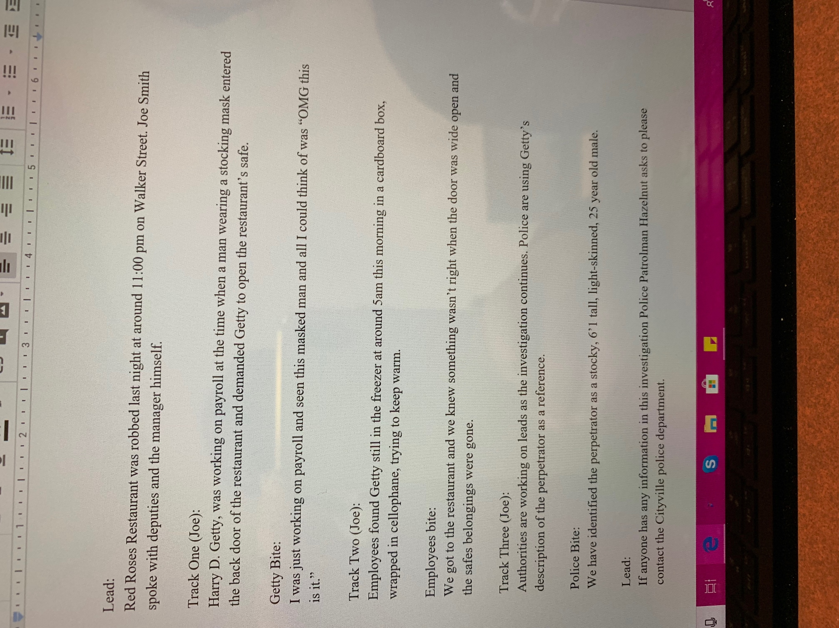

the aerosol spray can story

The Cityville Herald
An unusual incident at Willow Greek Park near Hays Crossroads left a six-year-old boy, Bobby Cannon dead during a family camping trip..
Bobby, the youngest son in his family, was playing at the park with his family when the incident occurred.
According to Bobby’s parents Robert and Reneta, Bobby died when an aerosol kept in the family vehicle exploded. Police report that Bobby was playing with the can at the time and accidently tossed it into the fire. According to a medical examiner, the blast sent pieces of shrapnel into his hand which penetrated his brain causing his instant death.
Time Cochran, Cityville fire chief said that the incident is unusual with the only previous incident being that of a woman killed by fire from an aerosol can. Out of 33 accidental deaths, only 2 of them involved aerosol can. The chief said, "If these products are handled properly, there is nothing to worry about." When mishandled they are lethal.
To control the incidents, Cochran sent a warning to his residents saying that they should avoid keeping aerosol cans near stoves, parked cars that have their windows rolled up and anywhere near heating units at home.

